# README for Grazioso Salvare - Bierbaum

## About the Project/Project Title

This project is to provide data from local animal shelters to external businesses and organizations. It includes a dashboard that displays animals that are available for adoption in the Austin area. The dashboard also includes features specific to Grazioso Salvare’s needs of finding rescue dog candidates quickly.

## Screenshots:

Starting state:  
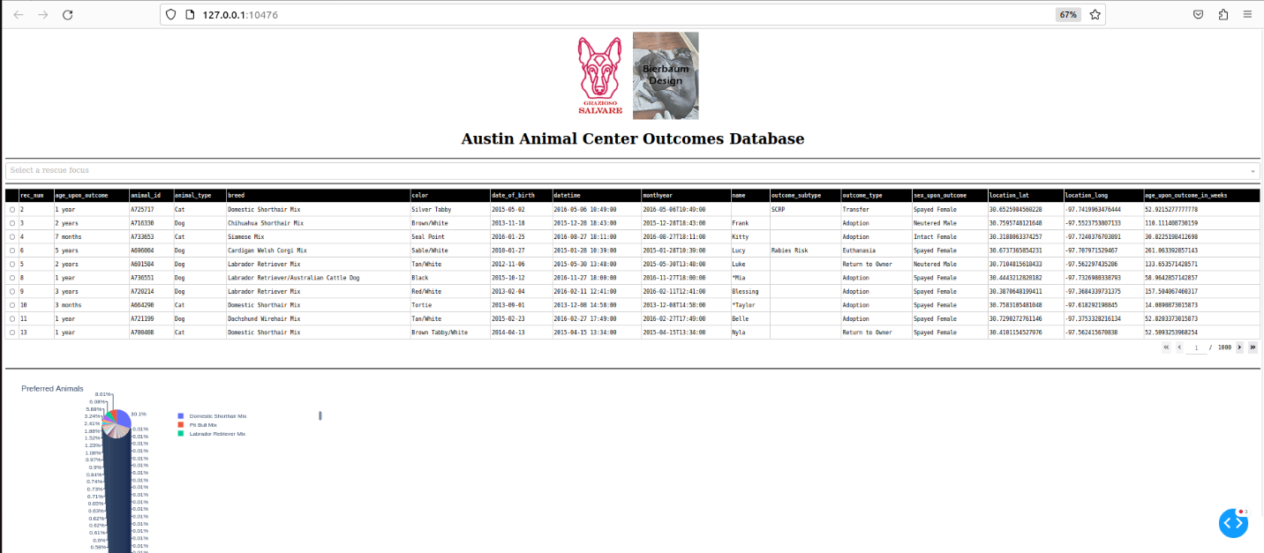

Water rescue filter:

## A screenshot of a map Description automatically generatedMountain rescue filter:

Disaster rescue filter:  
Reset filter:

**Tools used to complete the project:**MongoDB was used as the database for this project. It was chosen because it offers easy integration with Python, no SQL databases tend be quicker, and because the key-value structure of the MongoDB is more apt to modern development languages.

The Dash framework was used to build the UI and be able to visualize the data for the user.

**Project completion steps:**The first step to building this dashboard was to integrate the data into a MongoDB and set up a user that was able to access the database. Once that was complete, I built a Python service that connects to the database, authenticates, and performs basic CRUD (create, read, update, and delete) functions. The final steps were to build the UI with the Dash framework, then use the framework’s controller abilities to make changes and updates on the screen as requested by the client.

**Contact:**Marye Bierbaum